Week 2
Session 6:-
Program :-
class Solution {
public int[] buildArray(int[] nums) {
int[] ans = new int[nums.length];

for (int i = 0; i < nums.length; i++) {
ans[i] = nums[nums[i]];
}

return ans;
}
}
Output:-
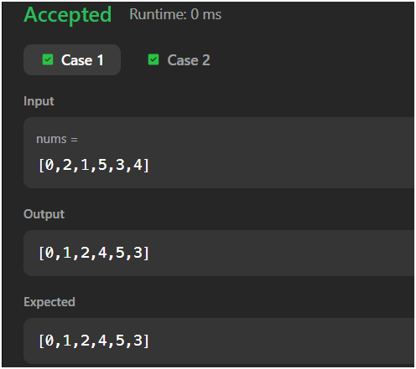
(2):-
Program:-
class Solution {
public int[] shuffle(int[] nums, int n) {
int[] ans = new int[2 * n];

for (int i = 0; i < n; i++) {
ans[2 * i] = nums[i];
ans[2 * i + 1] = nums[i + n];
}

return ans;
}
}
Output:-
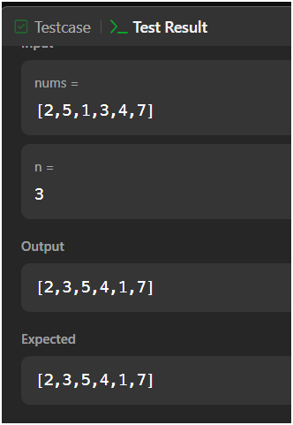
Session 7:-
class Solution {
public int removeElement(int[] nums, int val) {
int k = 0;

for (int i = 0; i < nums.length; i++) {
if (nums[i] != val) {
nums[k] = nums[i];
k++;
}
}

return k;
}
}
Output:-
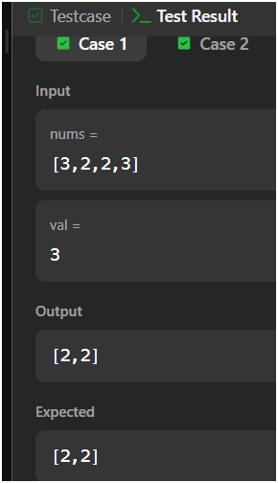
(2):-
Program:-
class Solution {
public int removeDuplicates(int[] nums) {
int k = 1;

for (int i = 1; i < nums.length; i++) {
if (nums[i] != nums[i - 1]) {
nums[k] = nums[i];
k++;
}
}

return k;
}
}
Output:-
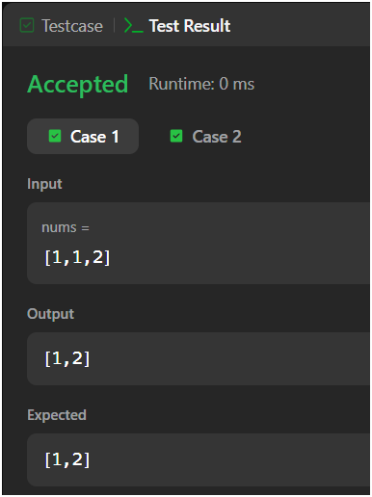
Session 8
(1):-
class Solution {
public int maxSubArray(int[] nums) {
int currentSum = nums[0];
int maxSum = nums[0];

for (int i = 1; i < nums.length; i++) {
currentSum = Math.max(nums[i], currentSum + nums[i]);
maxSum = Math.max(maxSum, currentSum);
}

return maxSum;
}
}

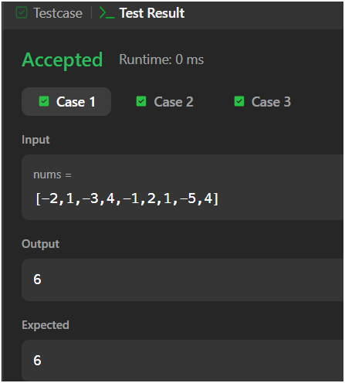
Output:-

(2):-
Program:-
class Solution {
public int largestAltitude(int[] gain) {
int altitude = 0;
int highest = 0;

for (int i = 0; i < gain.length; i++) {
altitude += gain[i];

if (altitude > highest) {
highest = altitude;
}
}

return highest;
}
}
Output:-
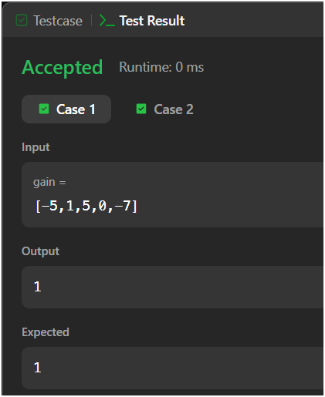
Session 9:-
(1):-
Program:-
import java.util.*;
class Solution {
public List<List<String>> groupAnagrams(String[] strs) {
Map<String, List<String>> map = new HashMap<>();
for (String str : strs) {
char[] chars = str.toCharArray();
Arrays.sort(chars);
String key = new String(chars);
if (!map.containsKey(key)) {
map.put(key, new ArrayList<>());
}

map.get(key).add(str);
}
return new ArrayList<>(map.values())
}
}
Output:-
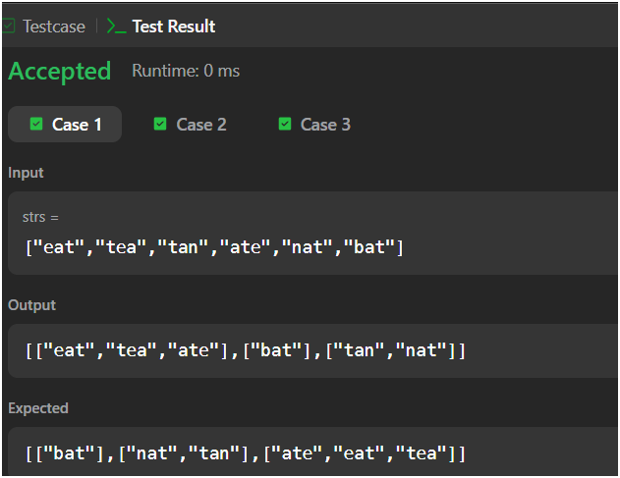
(2):-
Program:-
import java.util.*;

class Solution {
public int[] topKFrequent(int[] nums, int k) {

// Count frequency of each number
HashMap<Integer, Integer> map = new HashMap<>();

for (int num : nums) {
map.put(num, map.getOrDefault(num, 0) + 1);
}

// Min heap based on frequency
PriorityQueue<Integer> pq = new PriorityQueue<>(
(a, b) -> map.get(a) - map.get(b)
);

// Keep only k elements in the heap
for (int num : map.keySet()) {
pq.add(num);

if (pq.size() > k) {
pq.poll();
}
}

// Store answer
int[] result = new int[k];

for (int i = 0; i < k; i++) {
result[i] = pq.poll();
}

return result;
}
}
Output:-
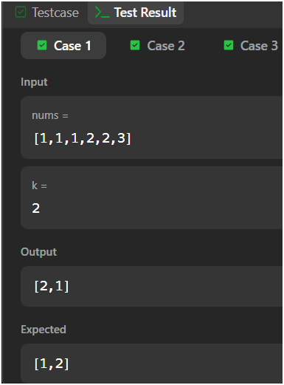
Session 10:-
(1):-
Program:-
import java.io.*;
import java.util.*;

public class Solution {

public static void main(String[] args) {
Scanner sc = new Scanner(System.in);

int n = sc.nextInt();
int m = sc.nextInt();

Deque<Integer> deque = new ArrayDeque<>();
HashMap<Integer, Integer> map = new HashMap<>();

int maxUnique = 0;

for (int i = 0; i < n; i++) {
int num = sc.nextInt();

deque.addLast(num);
map.put(num, map.getOrDefault(num, 0) + 1);

if (deque.size() > m) {
int removed = deque.removeFirst();

map.put(removed, map.get(removed) - 1);

if (map.get(removed) == 0) {
map.remove(removed);
}
}

if (deque.size() == m) {
maxUnique = Math.max(maxUnique, map.size());
}
}

System.out.println(maxUnique);

sc.close();
}
}
Output:-
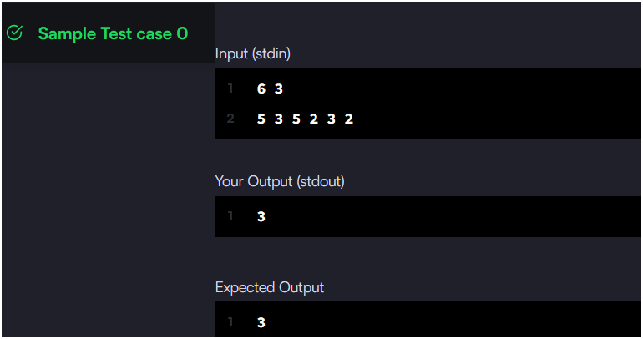
(2):-
Program:-
import java.io.*;
import java.util.*;
import java.text.*;
import java.math.*;
import java.util.regex.*;

public class Solution {

public static void main(String[] args) {
Scanner s = new Scanner(System.in);
int t = s.nextInt();
String [] pair_left = new String[t];
String [] pair_right = new String[t];

for (int i = 0; i < t; i++) {
pair_left[i] = s.next();
pair_right[i] = s.next();
}
HashSet<String> set = new HashSet<String>();

for (int i = 0; i < t; i++) {
String pair = pair_left[i] + " " + pair_right[i];
set.add(pair);
System.out.println(set.size());
}

}

Output:-
